1. Draw ERDs for each of the following. Draw softboxes, relationship lines, and labels for each relationship in both directions. Indicate non-transferability when appropriate.
a) Each message must be addressed to one or more persons. Each person may be the addressee of one or more messages.
b) Each clothing must have one and only one price. Each price may be for one or more clothes.
c) A person may be on one or more junk-mail lists. Each junk list may contain one or more persons.
d) Each school may be attended by one or more honor students. Each honor student must attend one and only one school.
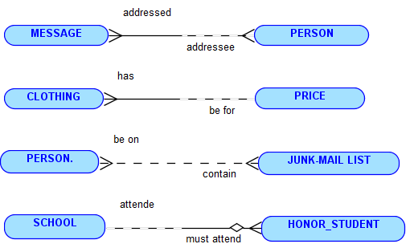
2. Are the following entities normalized? If not, make the necessary changes to correct it.
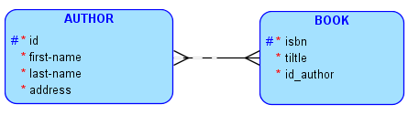

3. Resolve the M:M relationships.
